1. **Technical Events**
   1. **Achievements of Faculty Members**
2. **Dr. Bhuvnesh Bhardwaj** is awarded Ph.D. degree in July 2016 from [Sant Longowal Institute of Engineering & Technology](http://sliet.ac.in/), Sangrur, Punjab.
3. **Mr. Manish Jain** has been acted as Guest Editor of ISST Journal of Mechanical Engineering, vol.7 No.2 (July-Dec 2016), ISSN 0976-7371.
4. **Mr. Ananya Chattree** had **4 Citations** on earlier published paper, “A New Facile Route for Synthesizing of Graphene Oxide Using Mixture of Sulfuric–Nitric–Phosphoric Acids as Intercalating Agent, Physica: E, Elsevier Pub, p.p. 235” in this semester.
5. Many research/review papers have been published in International Journals during this semester. The details of them are as follows:

|  |  |  |  |  |
| --- | --- | --- | --- | --- |
| S# | Author(s) | Title of Paper | Journal/ Conference | ISSN |
| 1 | **Dr. M.P. Singh,**  **Ramphool Meena** | A SURVEY ON THE ADOPTION OF LEAN PRACTICES IN INDIAN MANUFACTURING SECTOR | IJIERD, Volume-7, Issue-2, July-2016, p.p. 52-62 | **0976-6987** |
| 2 | **Dr. M.P. Singh,**  **Anuj Singh** | MAJOR OBSTACLES AND RELATIONSHIP AMONG BARRIERS IN IMPLEMENTING LEAN MANUFACTURING IN INDIAN INDUSTRIES | IOSR-JMCE, Volume-13, Issue-4, July-2016, p.p. 80-86 | **2278-1684** |
| 3 | **Dr. M.P. Singh,**  **Shiv Singh** | STUDY OF THE PARAMETERS IN EDM THROUGH DESIGN OF EXPERIMENT USING TAGUCHI METHOD | IJIRSET, Volume-5, Issue-7, July-2016, p.p. 13542-13553 | **2319-8753** |
| 4 | **R.O. Rustagi,**  **Vivek Kumar,**  **Prabhat Kr. Ranjan** | IMPROVEMENT IN QUALITY BY KAIZEN GEMBA | IJME, Volume-7, No. 2, July-December 2016, p.p. 04-07 | **0976-7371** |
| 5 | **Manish Jain,**  **Dr. M.P. Singh,**  **Shubham Rathi** | OPTIMIZATION OF POWER THROUGH WASTE HEAT IN CEMENT PLANT | IJME, Volume-7, No. 2, July-December 2016, p.p. 13-16 | **0976-7371** |
| 6 | **Rajendra Kr. Gupta,**  **Hitesh Arora,**  **Nitin Chhabra** | GEOTHERMAL ENERGY UTILISATION AND MANAGEMENT | IJME, Volume-7, No. 2, July-December 2016, p.p. 30-34 | **0976-7371** |
| 7 | **Bhuvnesh Bhardwaj,**  **Varun Sharma** | A REVIEW ON THE INFLUENCE OF HEAT INPUT ON THE WELDABILITY OF QUENCHED AND TEMPERED STEELS | IJME, Volume-7, No. 2, July-December 2016, p.p. 35-40 | **0976-7371** |
| 8 | **Jaydev Varma,**  **Bhuvnesh Bhardwaj,**  **Pawan Kr. Sharma** | GREY–TAGUCHI METHOD TO MULTI RESPONSE OPTIMIZATION OF DRILLING PARAMETERS | IJME, Volume-7, No. 2, July-December 2016, p.p. 41-46 | **0976-7371** |
| 9 | **Dr. M.P. Singh,**  **Kuldeep Sharma,**  **Mohit Pareek** | ENHANCEMENT OF PRODUCTIVITY THROUGH LEAN MANUFACTURING: A CASE STUDY | IJME, Volume-7, No. 2, July-December 2016, p.p. 47-50 | **0976-7371** |
| 10 | **Vishwas Kr. Sharma,**  **Kedar N. Bairwa,**  **Raj Kumar Goswami,**  **Bhuvnesh Bhardwaj** | NEED FOR OPTIMIZATION OF MACHINING PARAMETERS USING DOE: A REVIEW | IJME, Volume-7, No. 2, July-December 2016, p.p. 77-83 | **0976-7371** |
| 11 | **Rajendra P. Bairwa,**  **Kedar N. Bairwa,**  **Bhuvnesh Bhardwaj** | OPTIMIZATION OF CO2 LASER CUTTING PROCESS PARAMETERS FOR MINIMUM SURFACE ROUGHNESS DURING THE CUTTING OF AISI304L STAINLESS STEEL | IJME, Volume-7, No. 2, July-December 2016, p.p. 84-89 | **0976-7371** |
| 12 | **Satyendra Kumar** | MODLING AND SIMULATION OF FEMORE BONE REPLACEMENT USING FUNCTIONALLY GREADED MATERIAL (AL2O3/AL) UNDER BENDING AND COMPRESSION LOADING | IJME, Volume-7, No. 2, July-December 2016, p.p. 90-93 | **0976-7371** |
| NOTE: GREEN [Faculty JECRC], BLUE [Student JECRC], RED [Outside JECRC] | | | | |

1. **Achievements of Students**

* **RTU Merit**

Mr. Himanshu Chopra secured 5th rank in RTU merit with overall 83.50%.

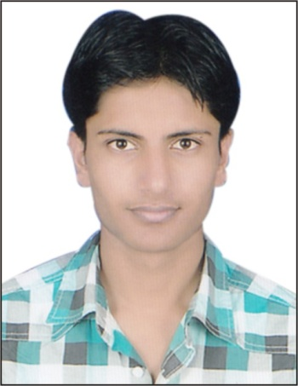

* **Robowar, IIT Guwahati**

Mr. Harshul Khandelwal, Mr. Aditya Yadav, Mr. Gaurav Lodha, Mr. Bhupendra Suman and three more members from Electrical Engineering secured 8th Position among 30 teams in ROBOACALYPSE, Techniche (Annual Tech-fest, IIT Guwahati), during 01-04 September 2016.

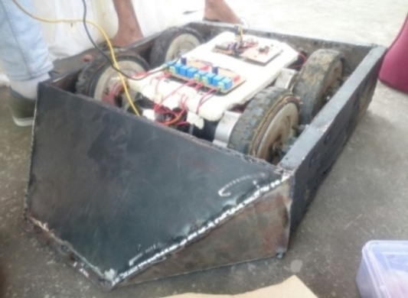 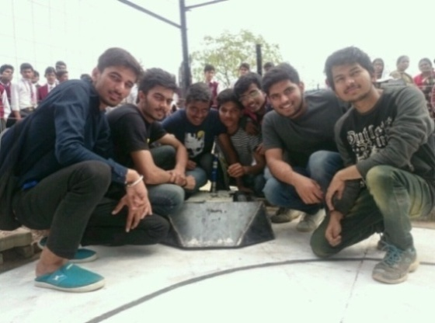

* **Best Paper Award**

Mr. Sumit Khurana (3rd Year) awarded with Best Paper Award in National Conference “RESSD-2016”, held during 07-08 October 2016 at JECRC, Jaipur.

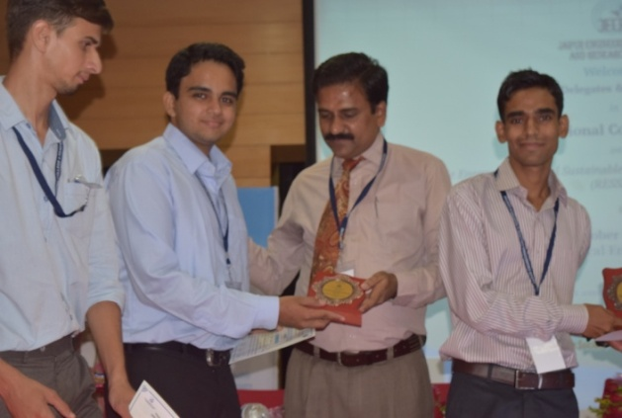

* **Best Paper Award**

Mr. Arun Shringi (3rd Year) awarded with Best Paper Award in National Conference “RESSD-2016”, held during 07-08 October 2016 at JECRC, Jaipur.

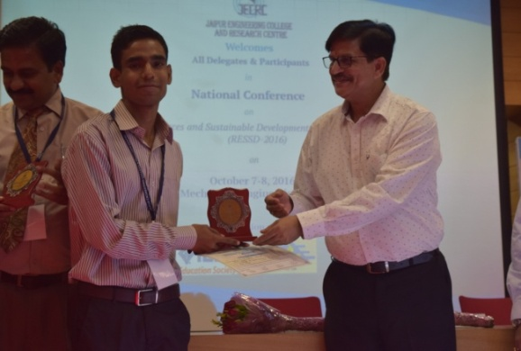

* **Automobile Mechanics & IC Engine [RENDEZVOUS - IIT Delhi]**

Mr. Pankaj Maharshi, Mr. Pankaj Sharma, Mr. Yash Sharma, Mr. Divyank Rathi, Mr. Sourabh Gupta, Mr. Yashwant Khandelwal, Mr. Himank Dave, Mr. Yeeshu Dwivedi and Mr. Rajat Shrivastav (all from 2nd Year) participated in Automobile Mechanics & IC Engine in “RENDEZVOUS” i.e. an Annual Cultural festival of IIT Delhi held during 21-24 October 2016 organized by Robosapiens Technologies Pvt. Ltd.

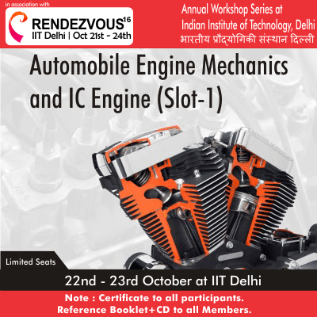

* **Mesh Flare [Techfest – IIT Bombay]**

Techfest is an annual fest of IIT Bombay. Our JECRC foundation students Sourabh Mangal and Satyam Jain both from 3rd Year) have been participated in MESH FLARE during Technorions at Techfest on 16-18 Dec. 2016 at IIT Bombay.

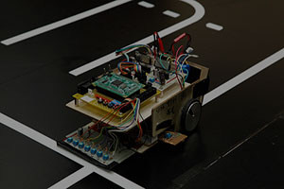

* **ROBOWAR**

Mr. Harshul Khandelwal (III Year) with his group participated in ROBOWAR at LNMIT during18th to 20th Jan, 2017 and won 2nd prize.

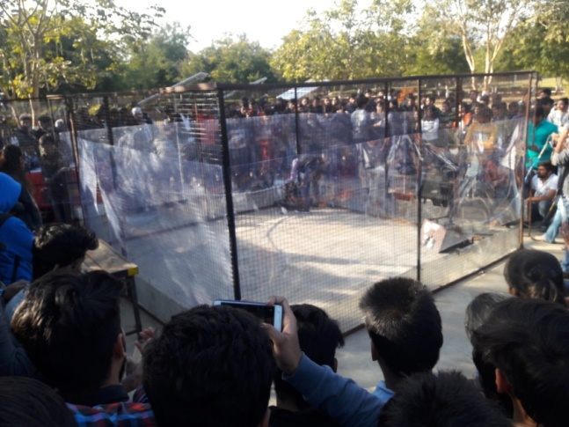 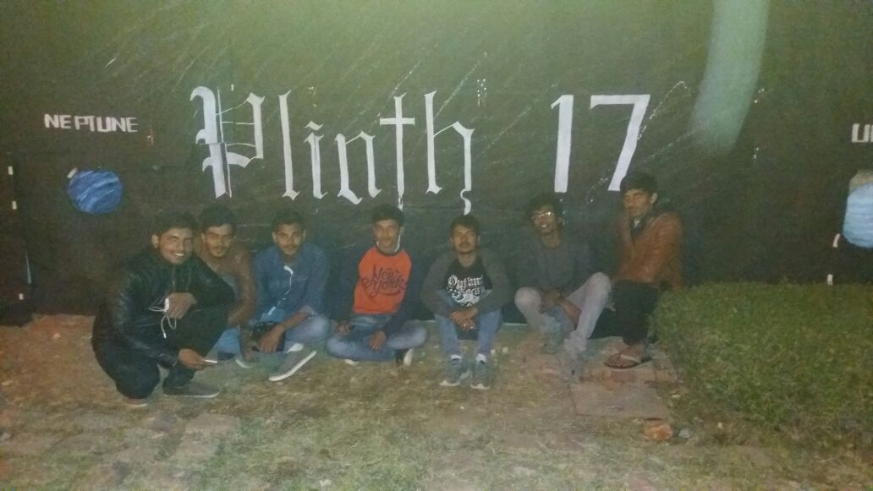

* **VIBGYOR**

Mr. Gourav Lodha (III Year) with his group participated in RC Car event at Baba Farid College of Engineering & Technology, Bhatinda during 27th to 30th Jan 2017.

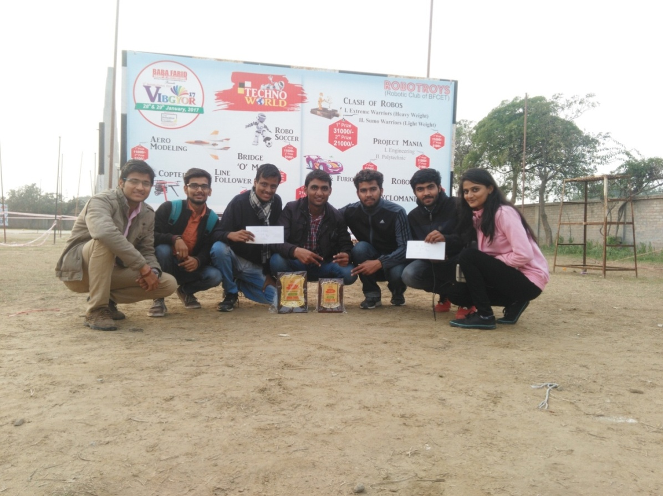

* **RC Car Event**

Mr. Arpit Natani (III Year) and Arpit Agarwal (III Year) participated in RC car competition at RTU, Kota during 15th -18th February 2017 and won 2nd prize.

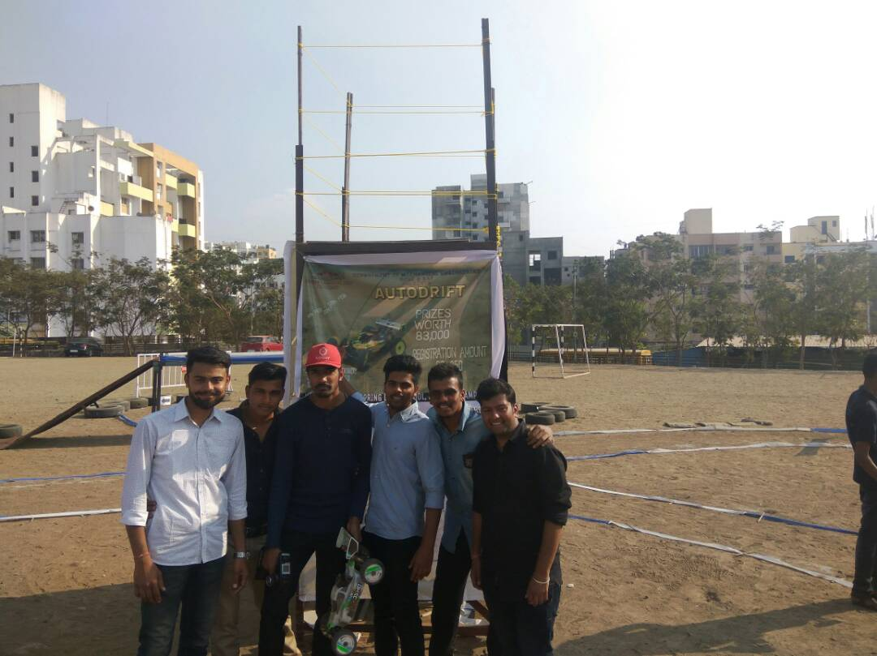

* **Elite Carting**

Moonrider Club of JECRC participated in a Go Cart event “Elite Carting” at Bhopal during 14th to 20th February 2017.

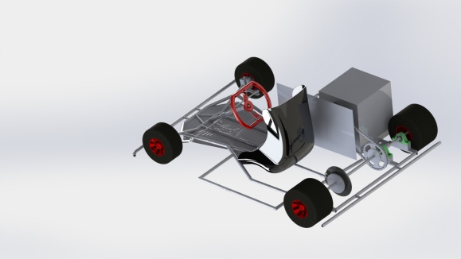 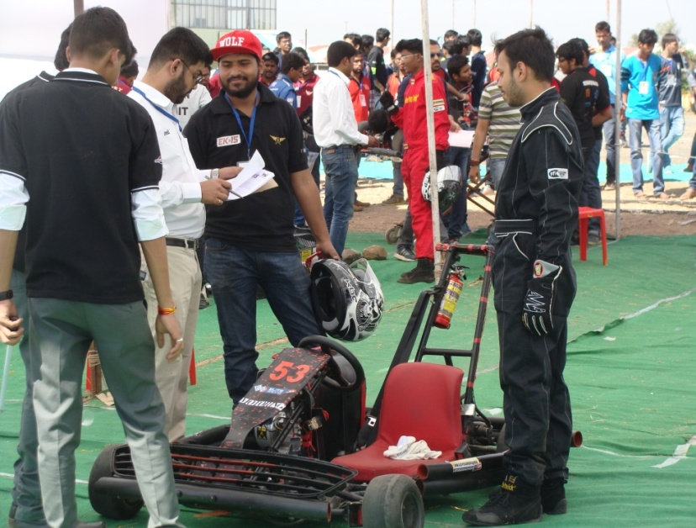

* **RC Car Event**

A team of 5 students participated in an RC Car event at MIT and DY Patil, Pune during 6th to 11th February 2017.

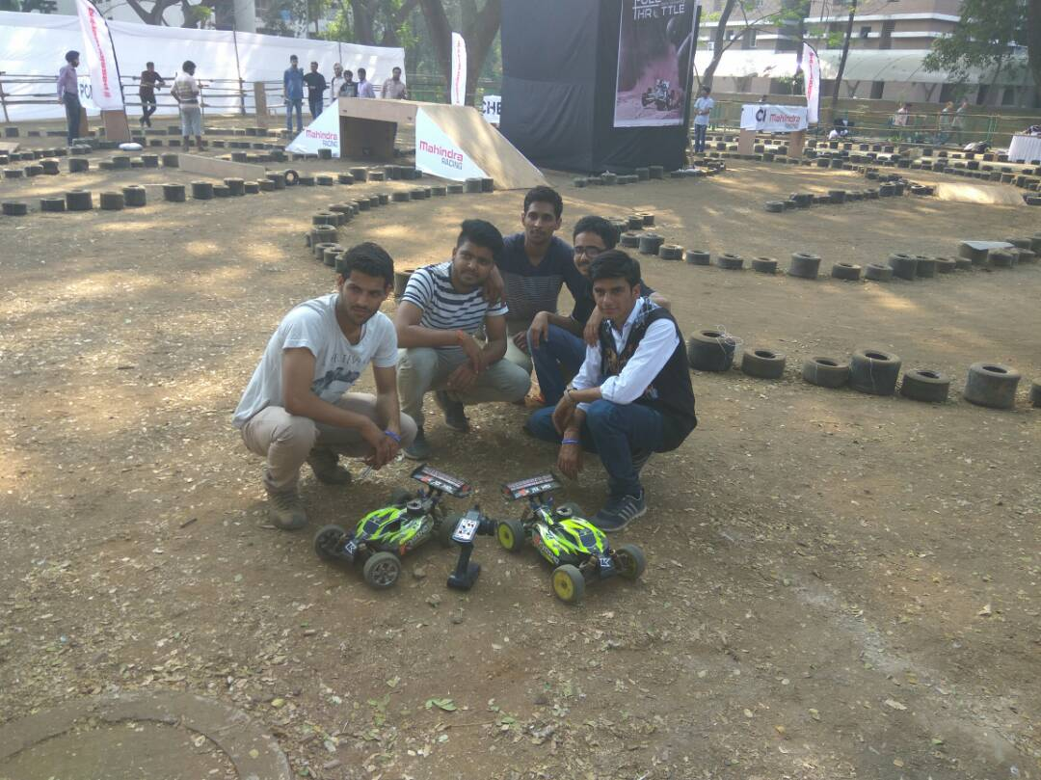

1. **Any significant contribution in teaching learning, innovation in teaching process, industry linked projects, internships etc.**

* **Conference [RESSD-2016]**

For a society to develop, it is necessary to have a vision, the ability to see what lies ahead, as well as the knowledge of various impediments in the present and of the means to arrive at a better future. The world around us is dramatically changing. It is becoming more and more interconnected through technology. Changing global conditions demand that we rethink the strategies of growth, and research is a tool to understand reality in order to make it a better living experience. Every walk of life is enriched due to research. It was scientific innovation that brought about the invention of a steam engine at a primitive level, thereby, making life easy at a click in the digital world. Research in its manifold pattern lays its foundation in diverse fields of Mechanical and Civil Engineering.

**OBJECTIVES:**

* To provide an exceptional platform to the academicians, researchers and students.
* To meet and discuss the practical solutions, scientific results and methods in solving various problems with people who are actively involved in emerging research fields.
* To focus on the recent technological developments in all the areas of renewable energy sources and sustainable development.

**About RESSD-2016:**

Department of Mechanical and Civil Engineering organized a Conference **“Renewable Energy Sources and Sustainable Development: Opportunities and Challenges”** during 07-08 October, 2016. The inaugural function was graced by the presence of Chief Guest **Prof. S.K. Ghosh, IIT Roorkee**. He motivated the faculty members and participants to contribute for upgrading the level of technical education with the help of research in their field.

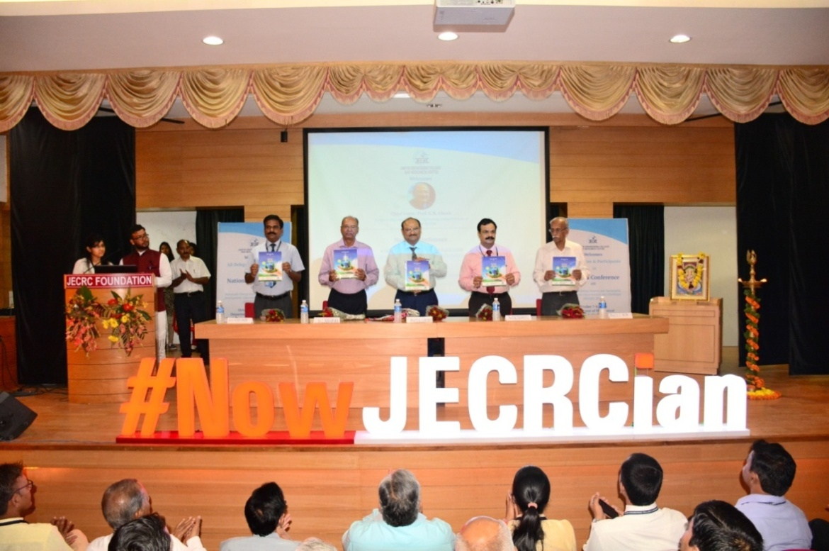

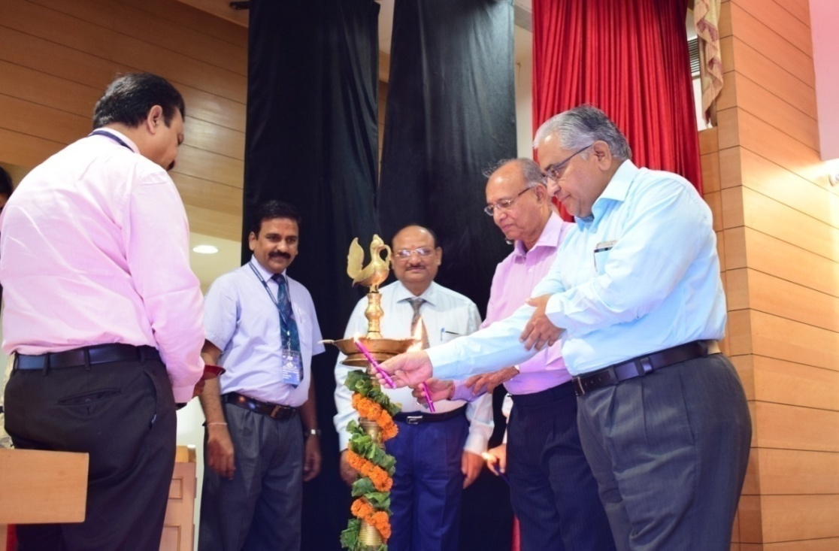

RESSD-2016 provided a unique opportunity of presenting and discussing recent advancement in renewable energy and sustainable development and made the bridge between academia and industries. The conference was consisting of scientific session, symposia on specific topics and paper presentation. A Group of experts shared information and got in touch with other groups. A special attention was also given to Green Manufacturing, Renewable Energy Sources for Sustainable Development, Green & Smart Construction and Future Fuels. Nowadays these aspects are becoming more and more important both in respects of human life and environment.

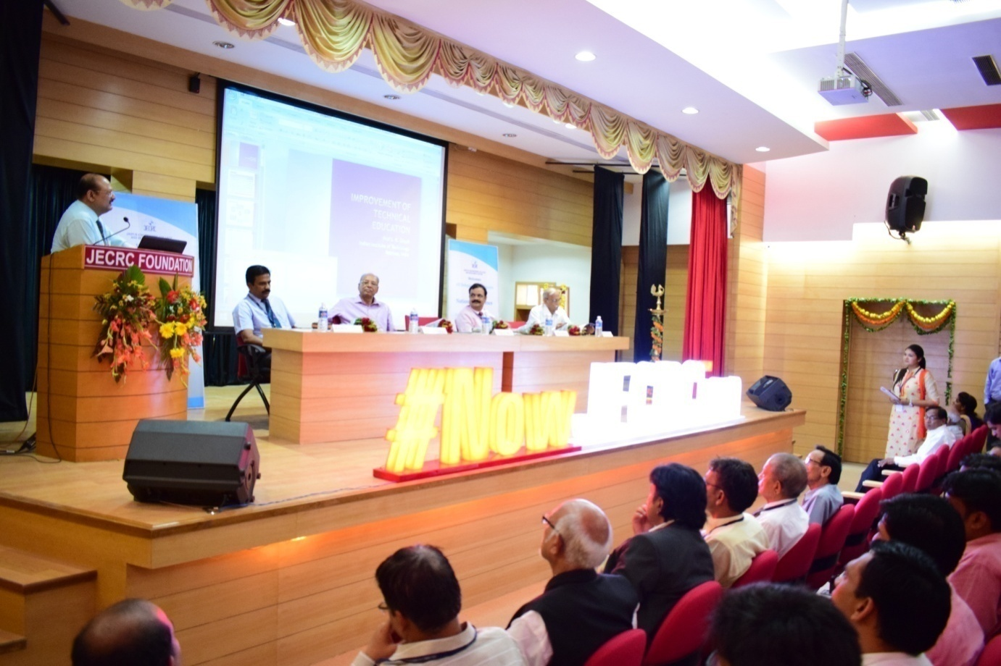

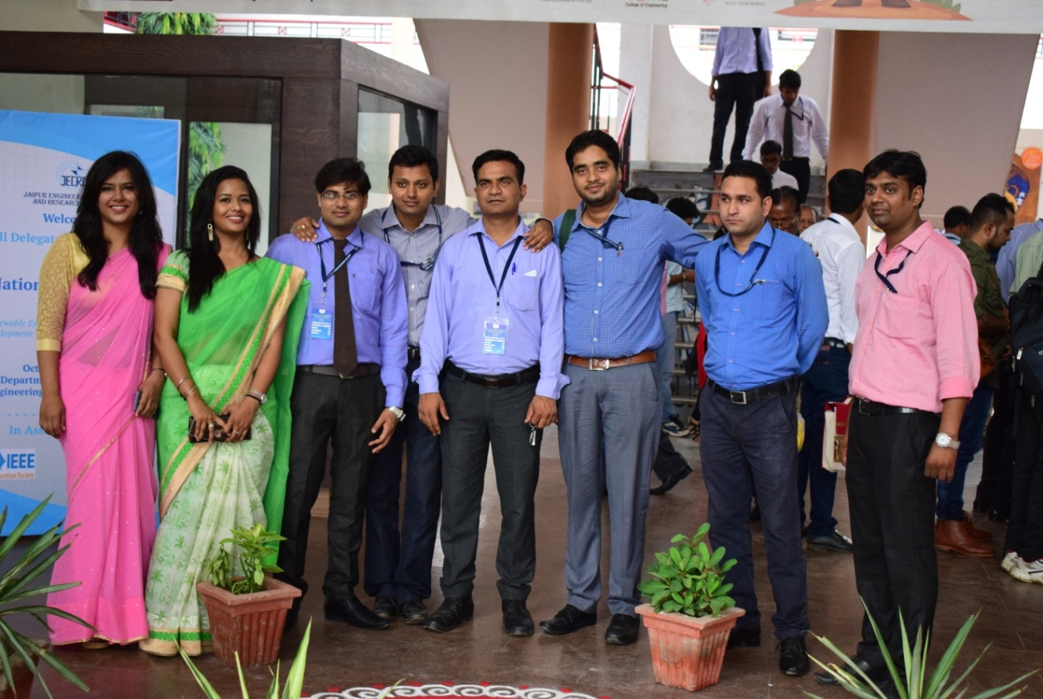

|  |  |  |  |
| --- | --- | --- | --- |
| Session | Chair Person | Designation | Number of Papers Presented |
| I | Mr. M.K. Bohara | Retired Chief Engineer, NHPC | 14 |
| II | Dr. P.N Dardey | HOD(CE), JNU, Jaipur | 12 |
| III | Dr. Anand Pandey | HOD(ME), MU, Jaipur | 14 |
| IV | Dr. M.L. Meena | Asst. Prof.(ME), MNIT, Jaipur | 14 |
| V | Dr. Jinesh Kumar Jain | HOD(ME), GCA, Ajmer | 14 |
| VI | Dr. K.B. Rana | Asst. Prof.(ME), RTU, Kota | 14 |

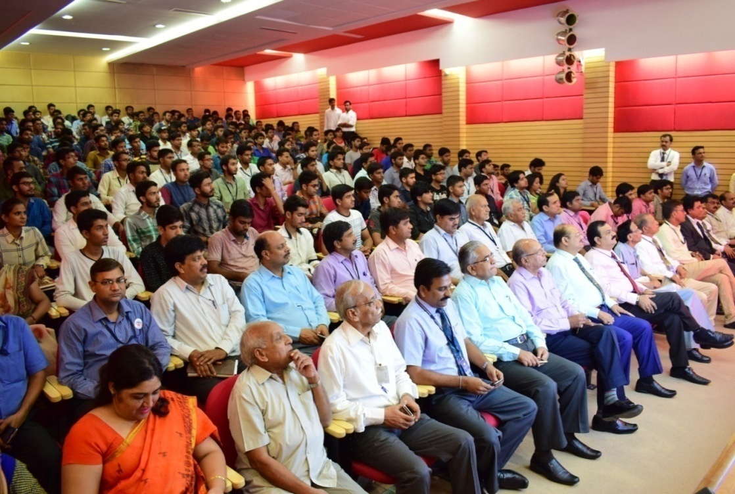

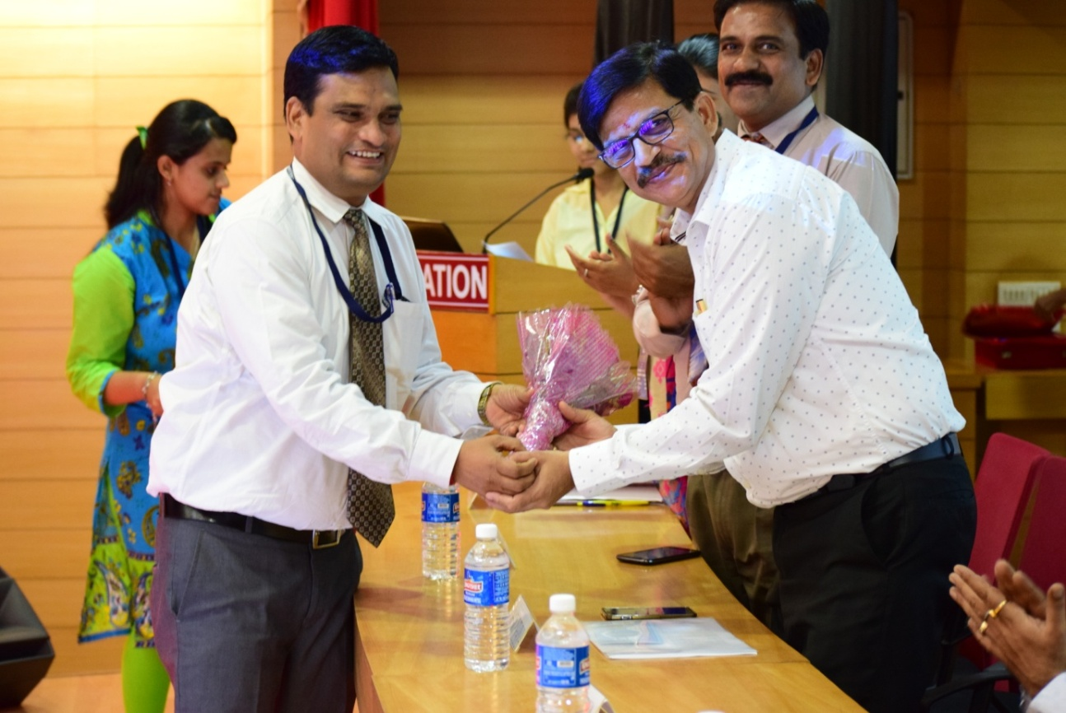

This conference was successfully conducted in association with IEEE Education Society, New Delhi and ISST Journal. **Prof. Dilip Sharma, MNIT**, expert in the field of Renewable Energy concluded the session with his words. He talked about the current status and ongoing research in the field of Renewable Energy.

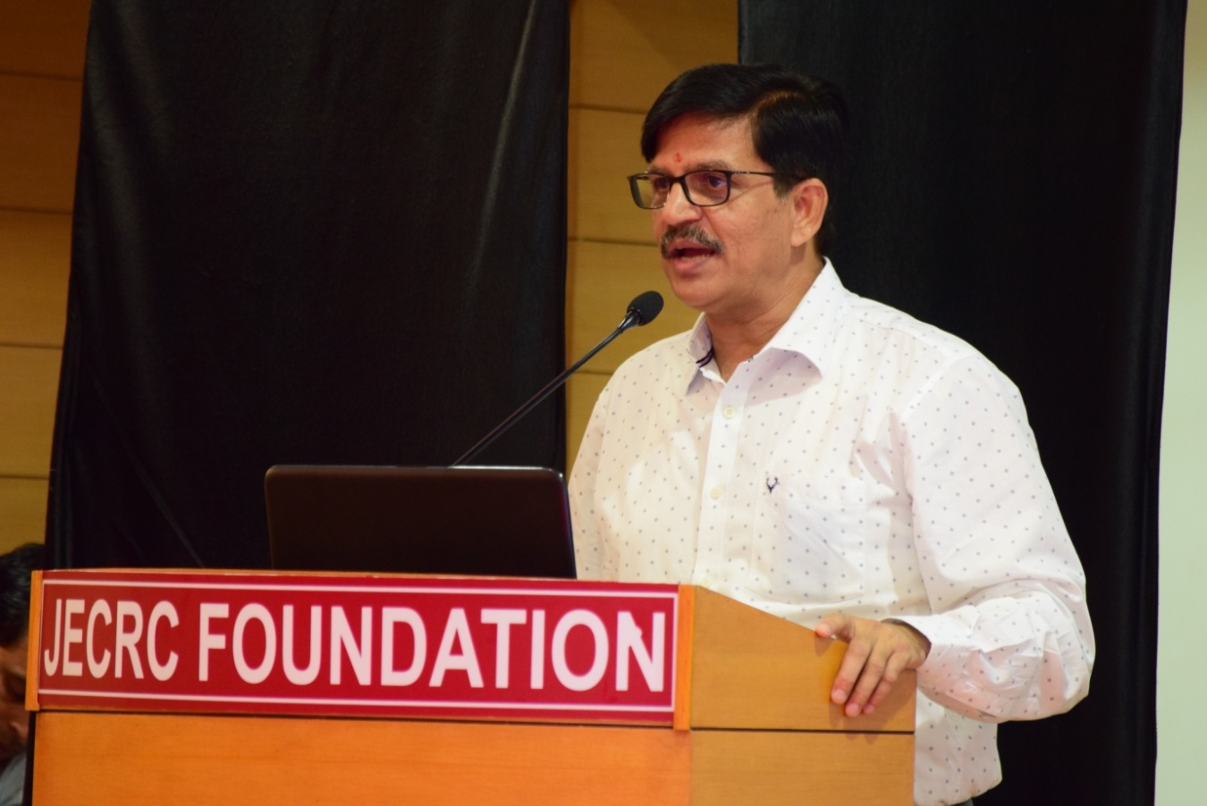

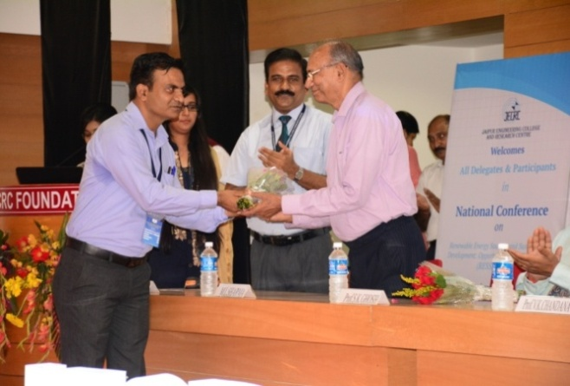 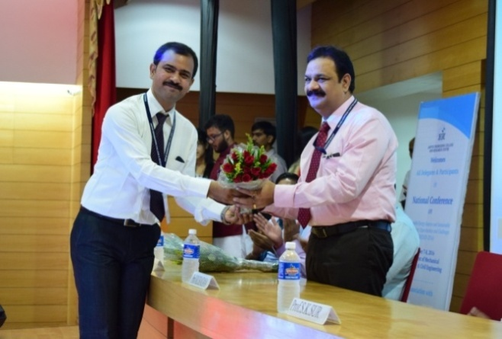

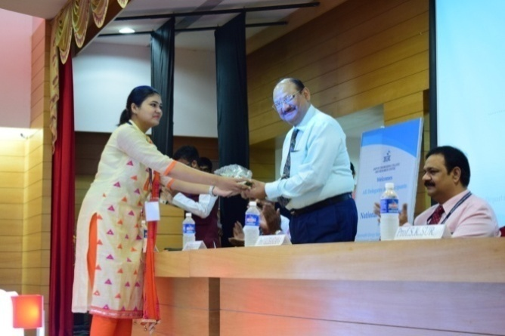

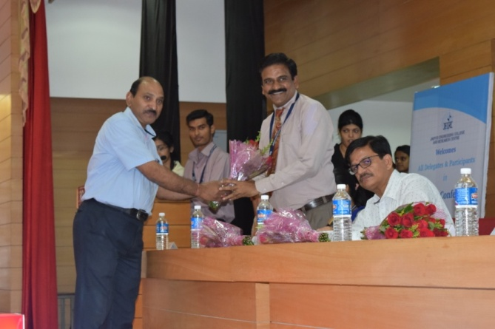 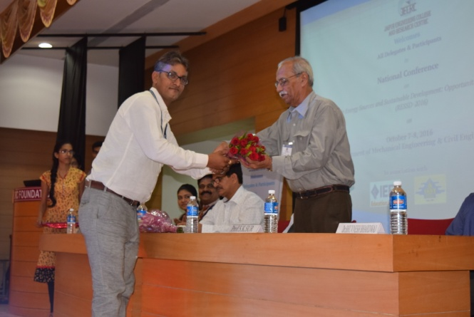

**HIGHLIGHTS:**

Total Number of papers received **103**

Total papers shortlisted **82 (out of 103)**

Outside Rajasthan **06 (out of 82)**

Selected for Publication in IJME [ISSN: 0976-7371] **39 (out of 82)**

**OUTCOMES**:

* Students and research scholars were made aware about the recent trends in the field of renewable energy.
* Students knew about the benefits of such conferences so that they may get an insight into the field of research which is an essential factor for the advancement of their career.

**5 DAY ANSYS WORKSHOP**

Department of Mechanical Engineering organized an short term course on “ANSYS DESIGN AND MODLING” in association ANSYS,India, during 07-11 November, 2016. Mr Alok (Indor) and Mr Beeru (Pune) came from ANSYS india and proved the detail use of ANSYS in solving the real world Problems. Several Handon session were also conducted for make students comfortable with the theory and softer More than 50 studnts from different colleges attended the workshop.

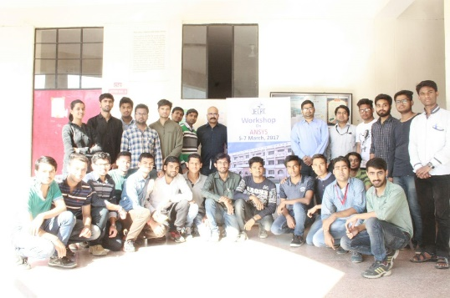

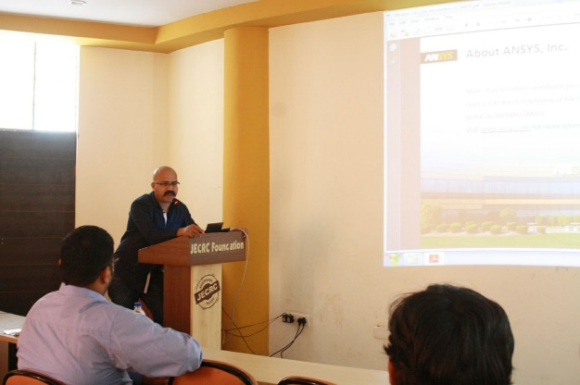

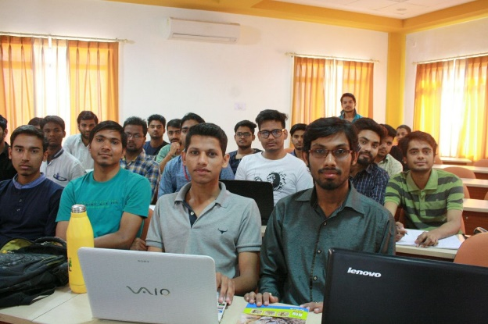

* **Faculty Development Programme**

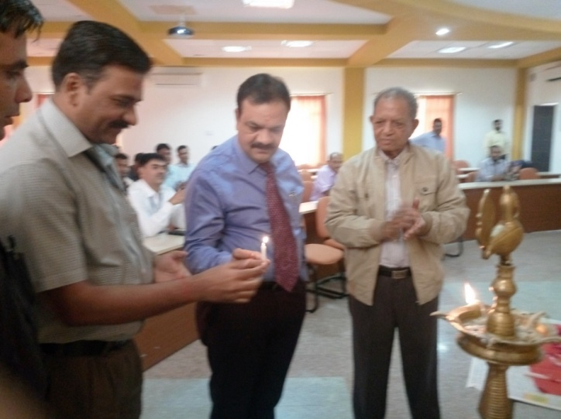Department of Mechanical Engineering organized an ICT based short term course on “New Manufacturing Technologies” in association with NITTTR Chandigarh during 07-11 November, 2016. The entire program was very satisfactory and learner-centric. On the day beginning after introduction, some aspects of manufacturing were discussed. The Programme was inaugurated by a chief guest Prof. V.K. Chandna (Principal JECRC).

**OBJECTIVES OF FDP**

The changing economics of production and distribution, along with shifts in consumer demand and the emergence of smart products, are pushing manufacturers to explore radically new ways of creating and capturing value. Emergence of new materials has resulted in new manufacturing techniques being used in the industry. The main aim of the program was to expose the participants to advanced manufacturing technologies including hybrid machining and additive manufacturing.

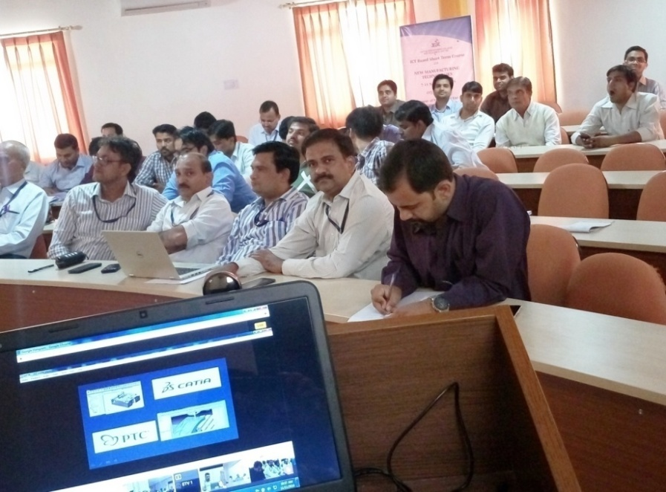

**HIGHLIGHTS:**

**[Session-I]** Shri Sunil Jassal delivered lecture on Advanced machining processes. He discussed Non-Traditional machining methods their needs, advantages and limitations.

**[Session-II]** Shri Alkesh Manna explained basic concept and need of Micro-mechanical electronic systems (MEMS) in mobile sensors, microprocessors, IC, Displays etc.

**[Session-III]** Prof. Rao delivered explained some basic concept on Rapid Prototyping. He also addressed the need of CAD, CAM and rapid prototyping.

**[Session-IV]** Prof. S. Paul delivered lecture on working principle of ECM. He told about the Potential drop in ECM, MRR models, Process Parameters, Applications and Limitations.

**[Session-V]** Dr. Sarbjit Singh explained conventional & non-conventional machining and basic concept of metal matrix composite, hybrid composite and type of reinforcements.

**[Session-IV]** Prof. Kansal took lecture on Nano Manufacturing towards Nano finishing. He discussed about basic concept of Nano technology and its application in various.

**[Session-VII]** Prof. Alakesh Manna continued his lecture. He explained working of various hybrid processes like AECG, AEGH, ECAM, ECDM, MAF, CAAFM, AEDM etc.

**[Session-VIII]** Dr. Atul Kumar emphasized on Wearing of gear under meshing and explained the wear phenomena with the help of laser scanning.

**[Session-IX]** Dr. J. P. Mishra explained some processes briefly with the help of schematic diagram his main focus was on Electro Chemical Honing (ECH).

**[Session-X]** Shri Sandeep Bhardwaj delivered lecture on Micro machining. He explained nonconventional micromachining processes with merits and demerits.

**[Session-XI]** Prof. Rao delivered lecture Overview of Product design and Development in this lecture. He explained CAD/CAM History and evolution of CAD/CAM.

**[Session-XII]** Prof. Sanjeev explained various concepts of nanoparticles in his lecture like aspect ratio, quantum confinement, and luminance.

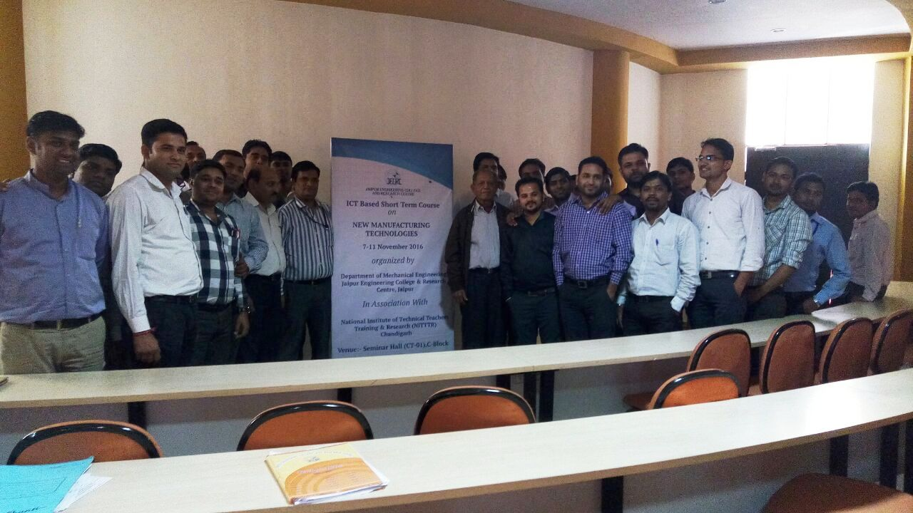

**OUTCOMES:**

Faculty members gained extensively details of new materials, manufacturing technologies, manufacturing processes, hybrid machining, additive manufacturing knowledge along with practical knowledge. Case studies and practical examples enriched faculty members concepts on above topics and that will help faculty members to conduct lab in institution. The advanced manufacturing technologies and manufacturing processes also benefited faculty members for upgrading the knowledge of students, so that they can easily interact with industry and make a strong bond between institution and industry.

* **RENAISSANCE 2017**
* **EMBRYO [**A paper presentation event on “Recent Trends in Mechanical Engineering”]

This Embryo aimed to tap the minds of budding mechanical engineers. In this regard, we had enclosed the poster of the Embryo. The events like paper presentation in the symposium helped students to think and come up with innovative ideas, also enhanced the on stage skills of the students. It also challenged the students ability apart from academic proficiency, helps in bringing out professionalism and volunteering traits from the individuals.

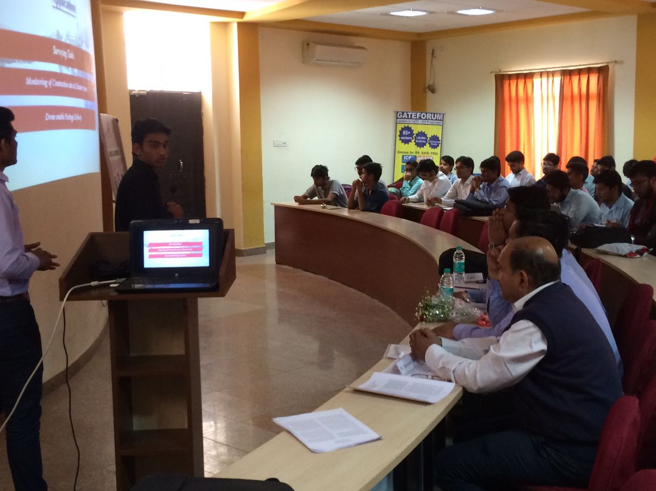

* **REVERSE ENGINEERING**

“Do you think... You know everything about Automobile Engine”, with this tag line we organized an event that requires in depth knowledge about various components involved in the assembly of an Automobile Engine. The participants disassembled and assembled the automobile engines in this event.

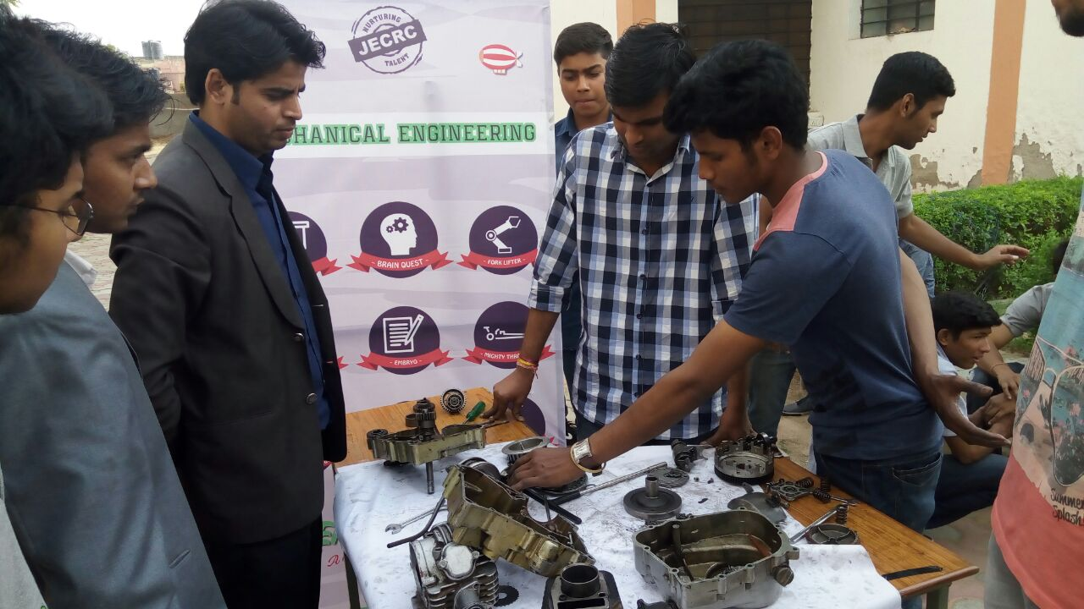

* **CADD MANIA**

This event was organized to examine the soft skills of students. In this event participant were challenged to design 3-D object on AutoCAD. This event was divided into two parts.

1. Quiz and 2D-drawing, and
2. 3D drawing and its all three views

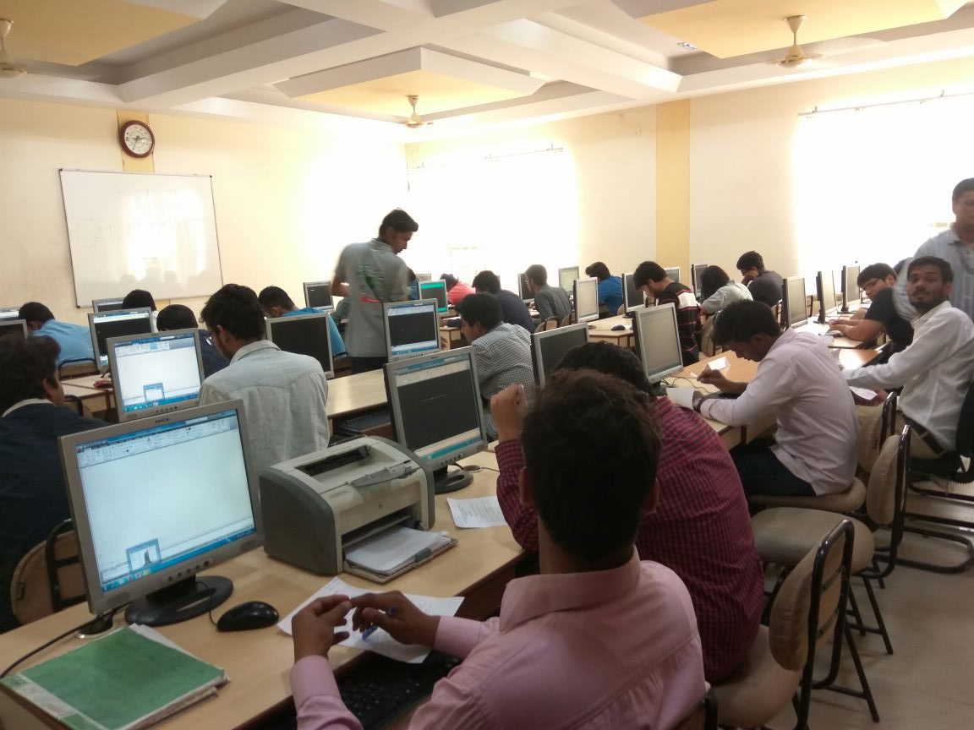

* **MIGHTY THROTTLE**

This event was organized for RC Car racers. The participants were instructed to build a Remote Controlled IC engine powered car to traverse a race track in the minimum possible time. The time track was composed of several turns with increasing difficulty levels.

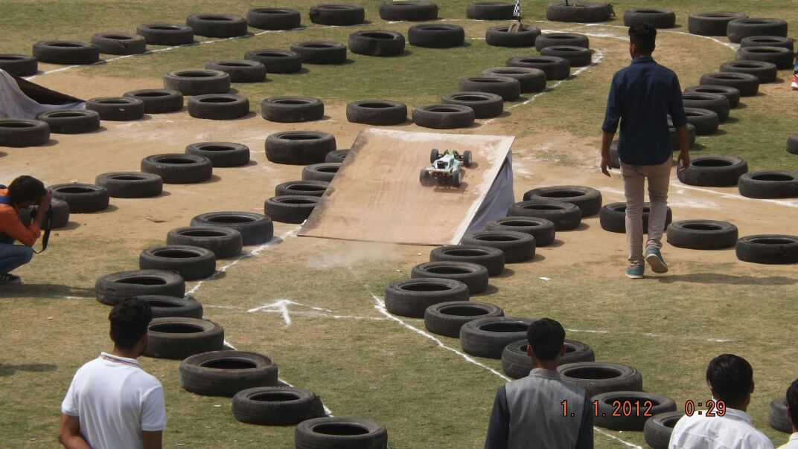

* **FORK LIFTER**

This event was about building a crane using wooden material suitable enough to place the given weights on a platform using only hydraulic mechanism. The participants showed their knowledge related to the field of linkage and hydraulic systems mechanism.

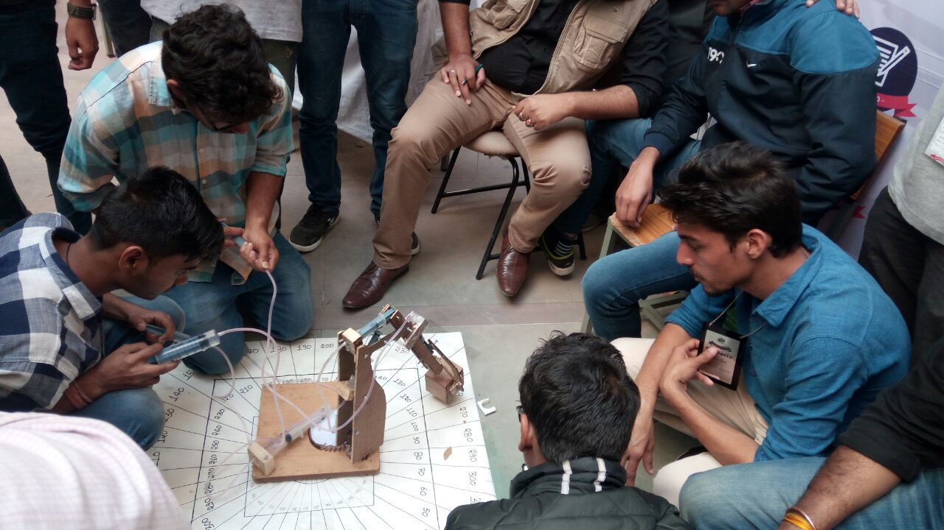

* **PROPELLO**

Propello was the event of making propulsion device with the use of compressed air. **The participants** were instructed to design and fabricate their own propulsion rocket powered with the help of pressurised water. Judging was done on the basis of time of flight, distance of path covered and trajectory of the device.

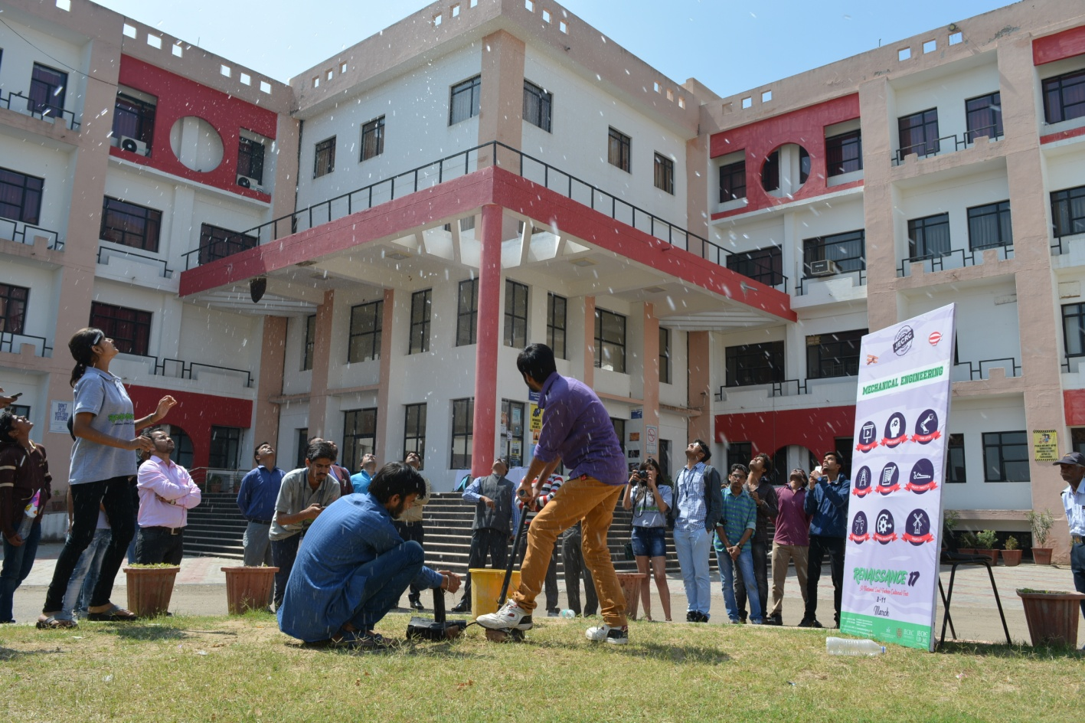

* **R-MECH OLYMPIAD**

This event was organized for JECRC students only. It was organized to test engineering aptitude for the Mechanical Engineering students.

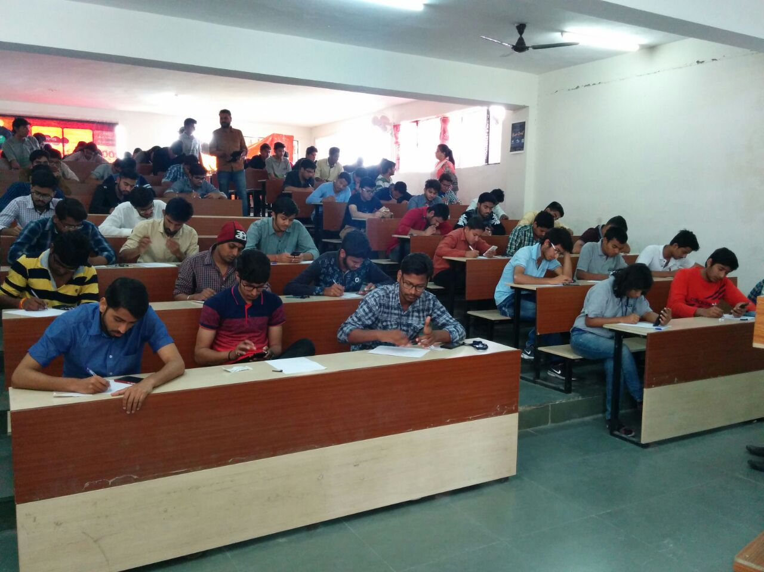

* **BRAIN QUEST**

This event was organized to test of knowledge, exclusively in Mechanical Engineering discipline as a competition between Individuals and Teams as a form of awareness.

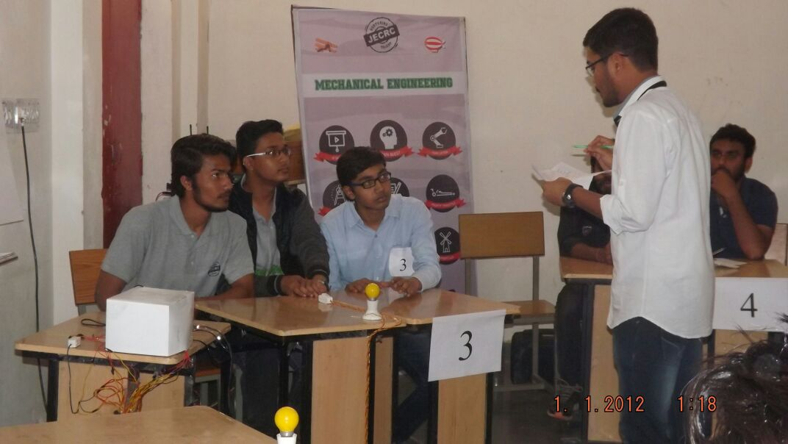

* **I V SHOW**

IVSHOW had the main motto to read the speed of Engineers mind. In this regard, we had enclosed the Innovative video competition which named as IVSHOW. This event gave the platform to the students to show their hidden talent with engineering innovative videos collection and motivates the rest of the students to think to be innovative.

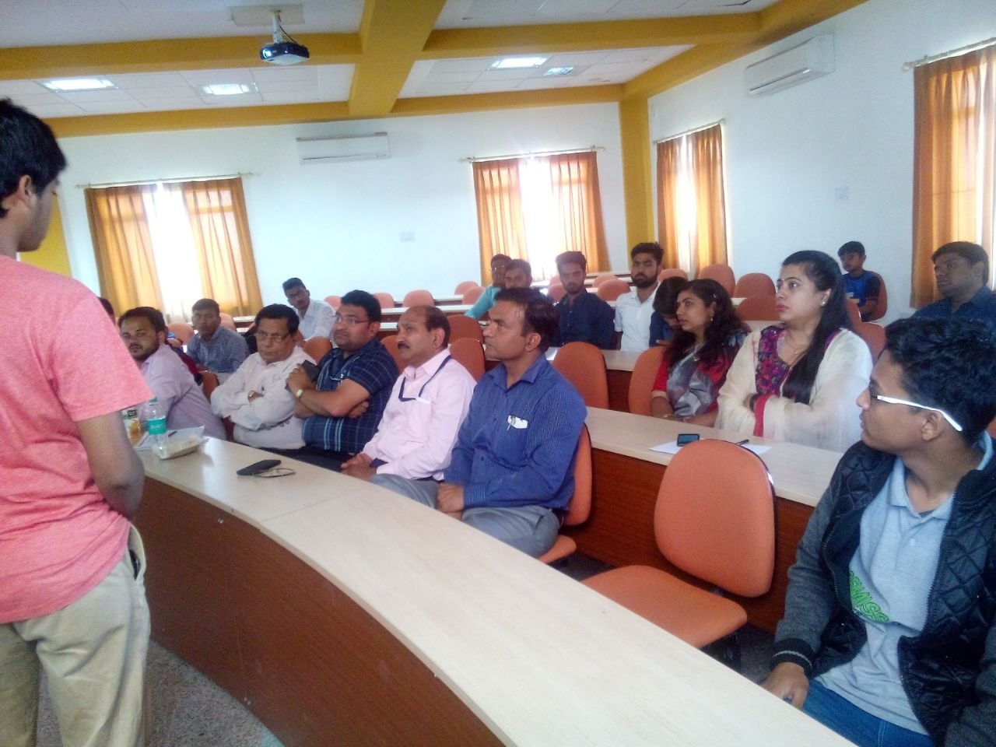

* **ANSYS Training Programme**

A group of 50 students along with 05 faculty members attended ANSYS training programme held at JECRC during 05-07 March, 2017.

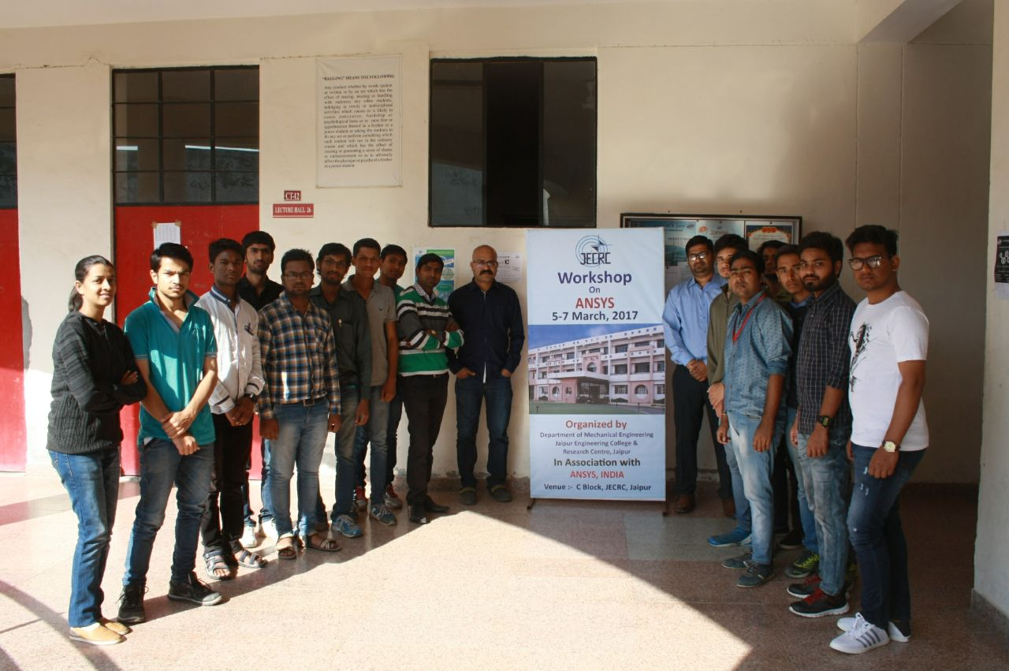

* **SAE Convention (North India)**

A group of 83 students along with 3 faculty members participated in SAE Convention held at Manipal University on 28th Jan, 2017.

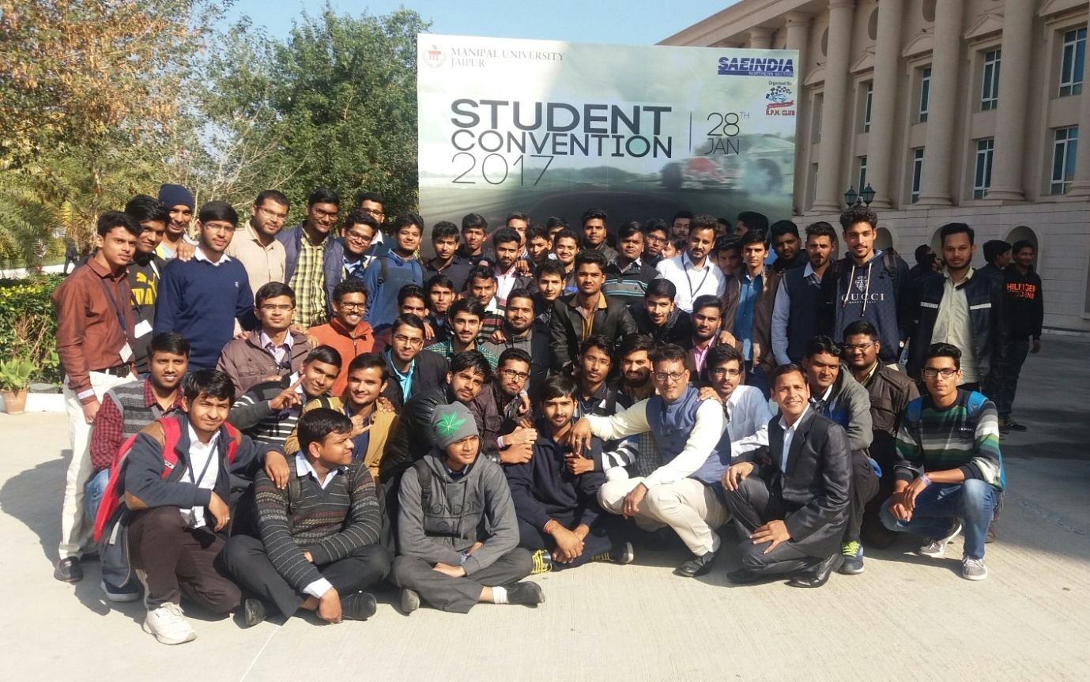

* **Industrial Visit**

A group of 30 students from 3rd year went for Industrial Visit at Manu Yantralaya, Jaipur on on 15th Feb, 2017 along with 2 Faculty members.

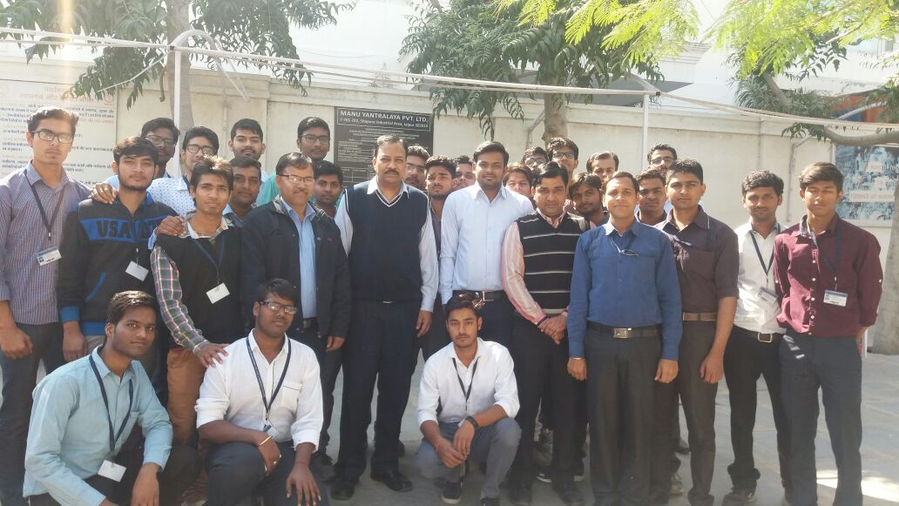

* **Guest Lecture on Career Counselling**

**Date: 29 August 2016**

**Speaker: Mr. Rahul (Director, GATE Academy, Bengaluru)**

We organized a guest lecture on Career Counselling on 29 August 2016. The speaker of this guest lecture was Mr. Rahul, Director of GATE Academy, Bengaluru. The speaker deeply explained about all the possible career options after the graduation. This guest lecture was informative and very useful for under graduates.

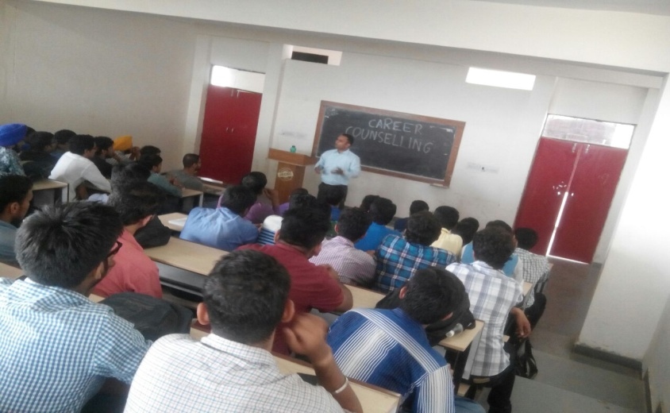

* **Guest Lecture on Introduction to Various Types of Automobile Engines**

**Date: 01 October 2016**

**Speaker: Mr. Nimesh Baba (Director, Baba Academy. Jaipur)**

We organized a guest lecture on Various Types of Automobile engines on 01 October 2016. The speaker of the guest lecture was Mr. Nimesh Baba, who is presently the Director of Baba Academy, Jaipur. In this lecture Mr. Nimesh Baba discussed about the various types of engines and explained the working of an automobile engine. He also discussed the mainly used engines in Automobiles.

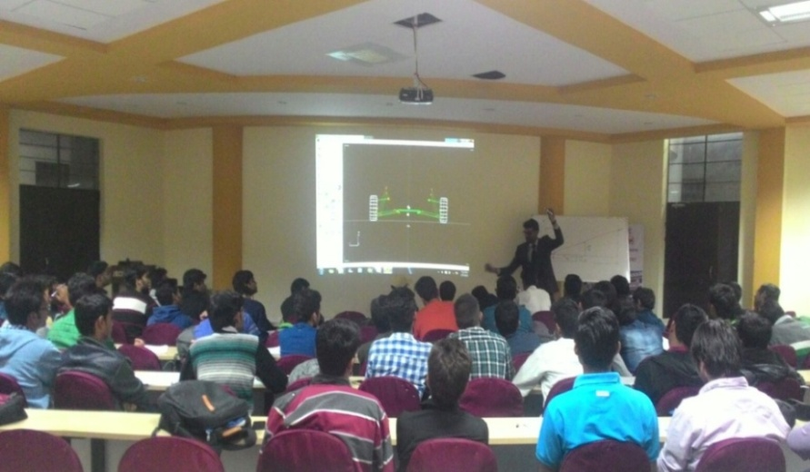

* **Guest Lecture on PSU Preparation**

**Date: 17 October 2016**

**Speaker: Mr. Pramod Vasist (Director, Engineers Academy, Jaipur)**

We organized a guest lecture for PSU preparation on 17 October 2016. The speaker of this lecture was Mr. Pramod Vasist, Director of Engineers Academy, Jaipur. The speaker explained about the PSU examination, syllabus and their exam patterns. This lecture was really helpful for the students.

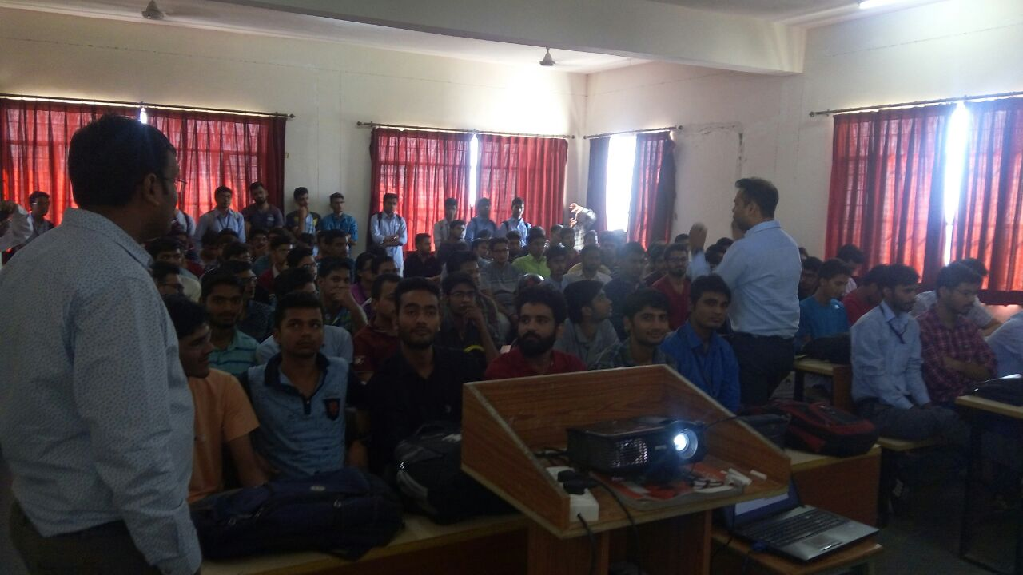

* **Work Shop on Assembling and Disassembling of 2 & 4 Stroke Engines**

**Date: 15-19 November 2016**

**Trainer: Mr. Nimesh Baba (Director, Baba Academy. Jaipur)**

We organized a four days workshop on assembling and disassembling of 2-stroke and 4-stroke engines from 15-19 November 2016. This workshop was aimed for practical training purpose of the students. The trainer, Mr. Nimesh Baba discussed the engines used in Automotive, Aircraft and Industrial applications. Participants disassembled and assembled 2-stroke and 4-stroke engines during this workshop.

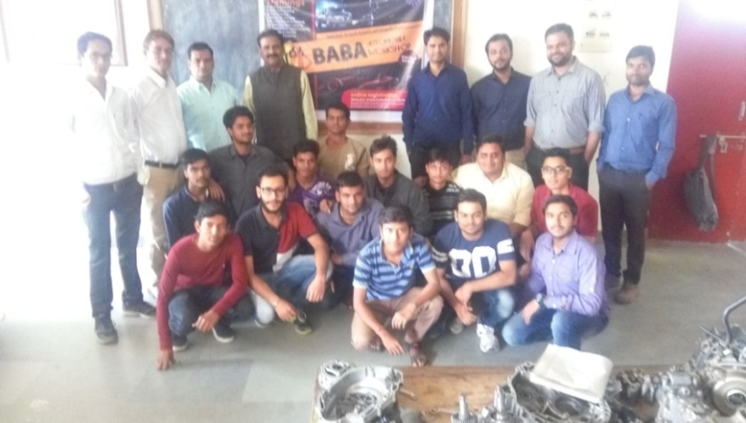

1. **Non-Technical Events**
   1. **Achievements of Faculty Members**

**[NIL]**

* 1. **Achievements of Students**
* **First in Chess**

Yeeshu Dwivedi (2nd Year) and Dhruv Laddha (ME 3rd Year) have won first prize in Inter College Tournament of RTU, Kota organised by Poornima College of Engineering during 22-24 August 2016.

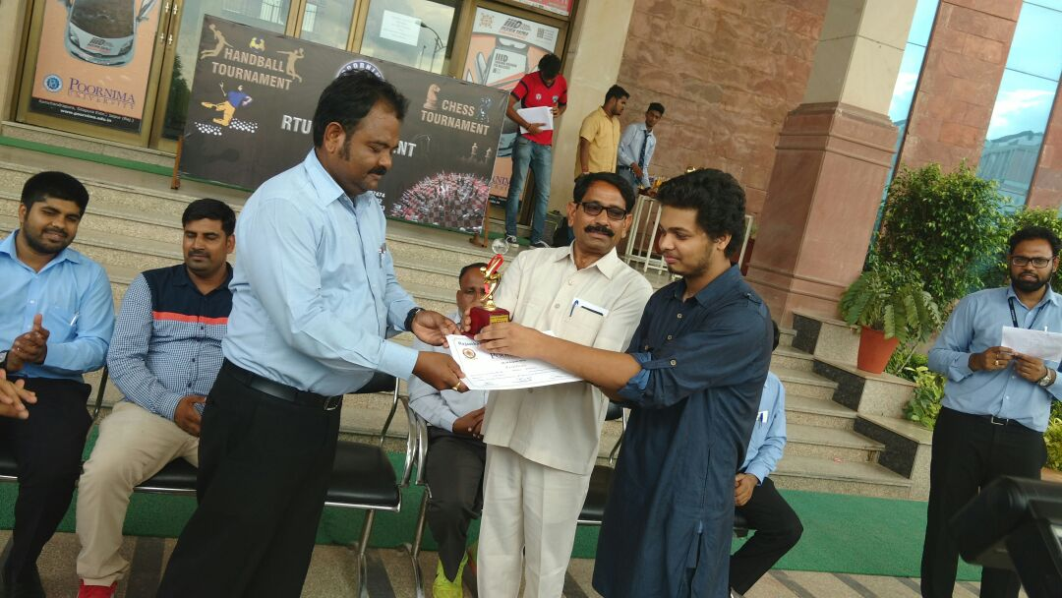

* **Winner in Swimming Competition at BITS**

Rajat Shrivastav (2nd Year) won Silver Medal in Freestyle-100m and Bronze Medal in Freestyle-400m in National Level Competition held at BITS, Pilani during 15-19 September 2016.

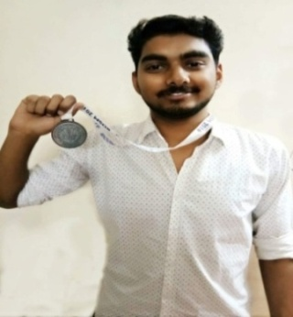

* **Winner of Debate Competition**

Mr. Shubhank Sharma (3rd Year) won debate competitions on “GST” in Hindi and English both, held during 13-14 October, 2016 at GIT, Jaipur.

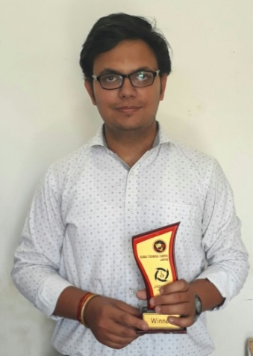

* **Hindi Quiz Winner**

Mr. Shubham Khandelwal (3rd Year) participated and won 1st prize in Hindi Quiz Competition (Jigyasa) held at Global Technical Campus, Jaipur from 13-15 October 2016.

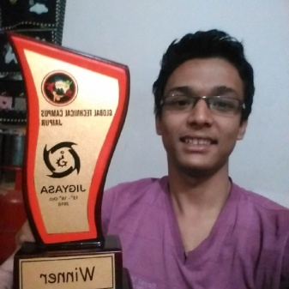

* **RTU Football Winners**

Mr. Shobit Yadav and Mr. Himanshu Acharya (both from 3rd Year) with their team won the RTU Football Tournament held at Arya College of Engineering, Jaipur on 27th October 2016. Our team defeated the team of RIET College, Jaipur by 4-1.

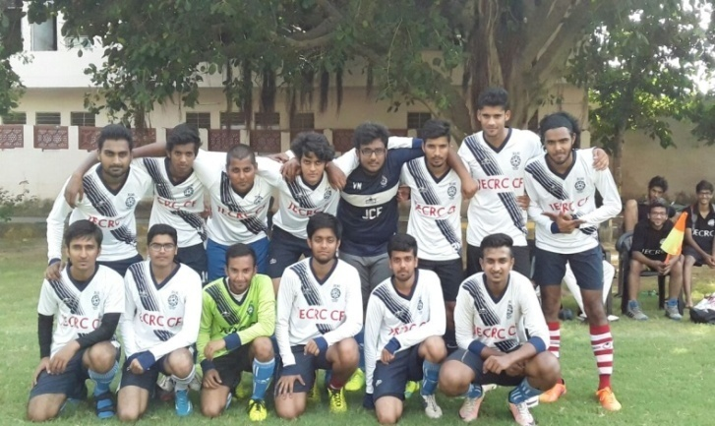

* **MUN Conferences**

**Mr. Shubham Gupta** (IV Year) participated in various **MUN conferences** during July-December 2016 and won two **2nd prizes** and **four 3rd prizes**.

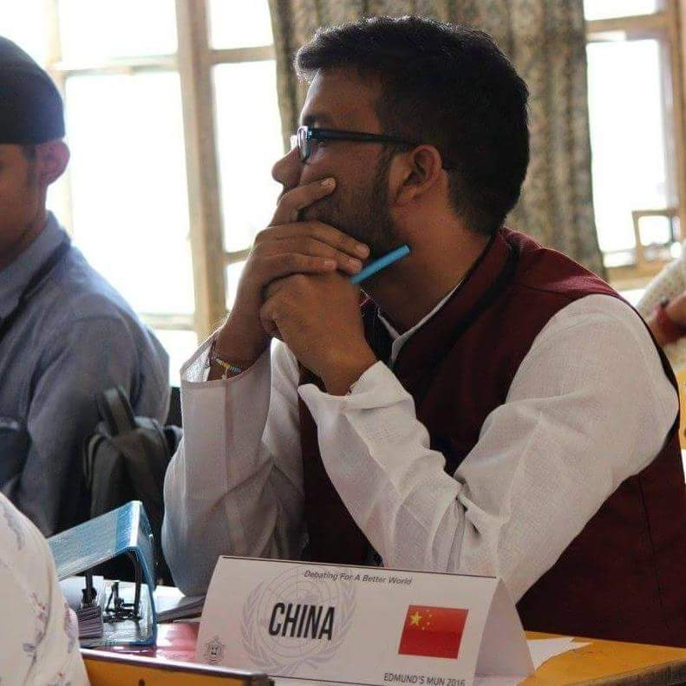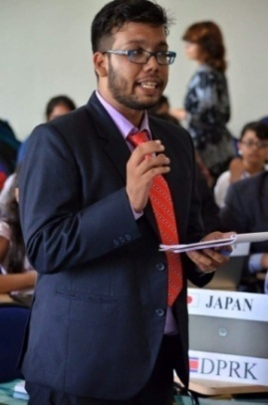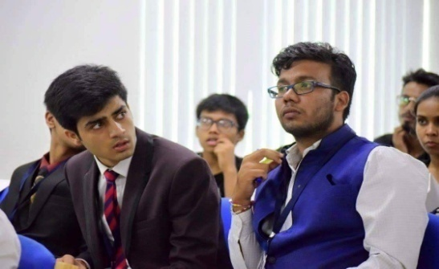

* **Kumar Memorial Awards for Public Speaking**

This event was focused on nurturing the talent of Public Speaking. It **was organized in 3 levels**, Mr. Shubham Gupta (IV Year) **appeared for second level** which hosted college students and **won 2nd prize**.

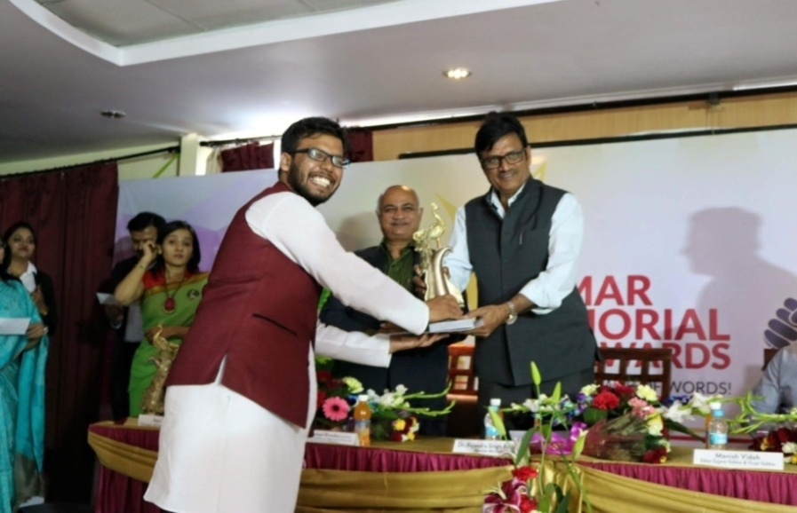

* **Debate**

Mr. Sumit Khurana (III Year) and Shubham Khandelwal (III Year) participated in a Debate competition at SKIT, Jaipur on 15th February 2017.

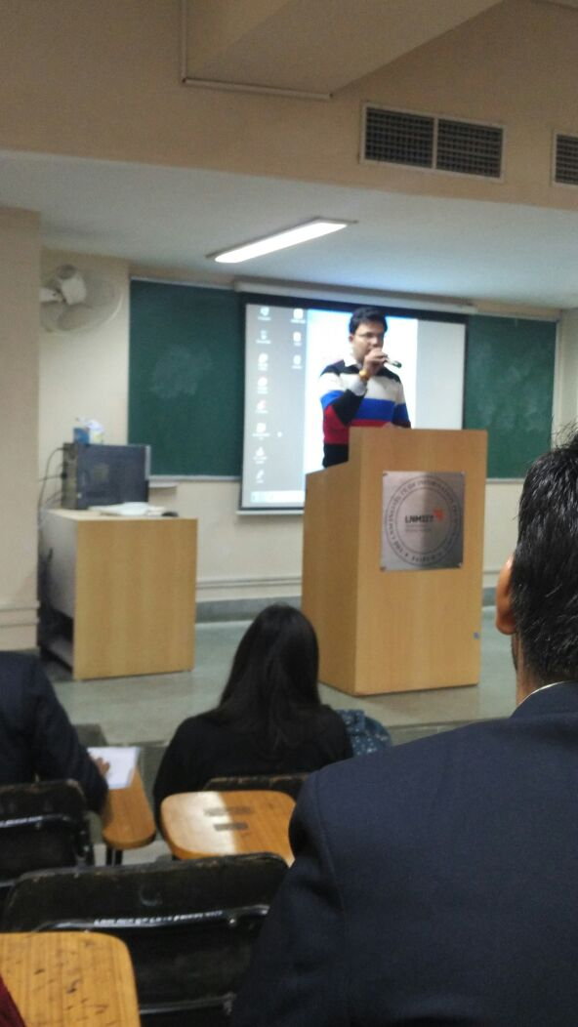

* JECRC badminton team won first prize in VANQUISH held during 24th march to 26th march at Global Technical Campus.

